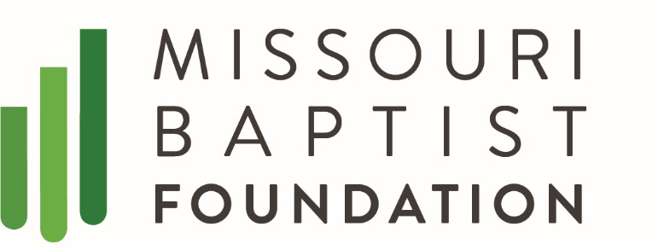
March 16, 2020
Pathway Publication March 24, 2020
Kim Quinn 573-462-6643

As our global community navigates the personal and business implications of COVID-19, the Missouri Baptist Foundation (MBF) wishes to help Missouri Baptist churches. We want to serve your church’s needs while you are caring for the ministry needs of your congregation.
Knowing that with the restrictions on sizable gatherings you will likely be cancelling Sunday services, we estimate that many within your congregation may forget to mail in their tithes and offerings. Perhaps you are concerned about how to keep your church’s offering money coming in while your Sunday services have paused. By registering your church with MBF, you and your church will have access to three convenient ways to support your continuing ministry efforts.
- Give Online at www.mbfn.org. A gift can be made to any Missouri Baptist church with a credit/debit card or check from the comfort of home. It can be designated to your home church by a simple request. Once your church official has called and added your church’s name to the MBF list, any interested donor can go to www.mbfn.org and make a designation to your specific church. LifeWay has a fee they administer to the front end of the giving. (2.69% + $.30 for credit card transactions and $0.30 for Echecks)
- DOWNLOAD the GENEROSITY by Lifeway APP. Another way to give is to download the free Lifeway Generosity APP. Upon opening the APP search for Missouri Baptist Foundation. Create an account by calling MBF then, select your church from the designation list. (Your church must be registered through MBF before this option is made available). Again the fees on credit and debit is the same as the text to give, echeck not available.
- Text to Give at 52014. Another convenient giving option is to send a text. Once your church’s name has been entered, all you have to do is text to 52014, type “@mbf” the word “give” the churches unique identification, the dollar amount you want to give and then hit send. You will receive a secure link to confirm your gift. Click on the link to complete the transaction. You can type “back” at any time to stop the process. (The same fees apply as above, giving by Echeck is not available) Donors do have the ability to include the cost of the transaction in the total amount they donate.
While there are other online giving alternatives with slightly lower fees, MBF is providing a solution for churches who do not have the ability or wish to invest in managing their own online giving options.

We are doing everything possible to help you and your church with your financial needs. If you want your church information added to our giving lists, desire information emailed out to you about other services or simply want to call with additional questions, your MBF is here for you at 800-776-0747.
As Rev. Greg Laurie says, keep three things in mind while dealing with this Corona Virus. Remain PRACTICAL, wash your hands often, don’t shake hands or hug friends, PRAYERFUL, remember those sick and the caregivers including medical professionals, and PROCLAIM your great hope through Christ Jesus.
MBF staff and trustees are praying for Missouri Baptists through these unprecedented days.

